6.4 Code Coverage with Clover
This section will guide you to:
- Perform code coverage using Clover in Jenkins for a Maven application.

This guide has four subsections, namely:
6.4.1 Login to Jenkins
6.4.2 Add Clover in Jenkins and Maven project
6.4.3 Create Jenkins job for Maven
6.4.4 Push code to GitHub repositories

Step 6.4.1: Login to Jenkins
- Open your browser and navigate to localhost:8081
- Provide your username and password and click on Login.
Step 6.4.2: Add Clover in Jenkins and Maven project
- Click on the eclipse executable in /opt/eclipse or run the following command in the terminal to open eclipse in your lab.
opt/eclipse/eclipse
- Create a basic Maven project in Eclipse.
Click on File->New ->Project-> maven->maven project.

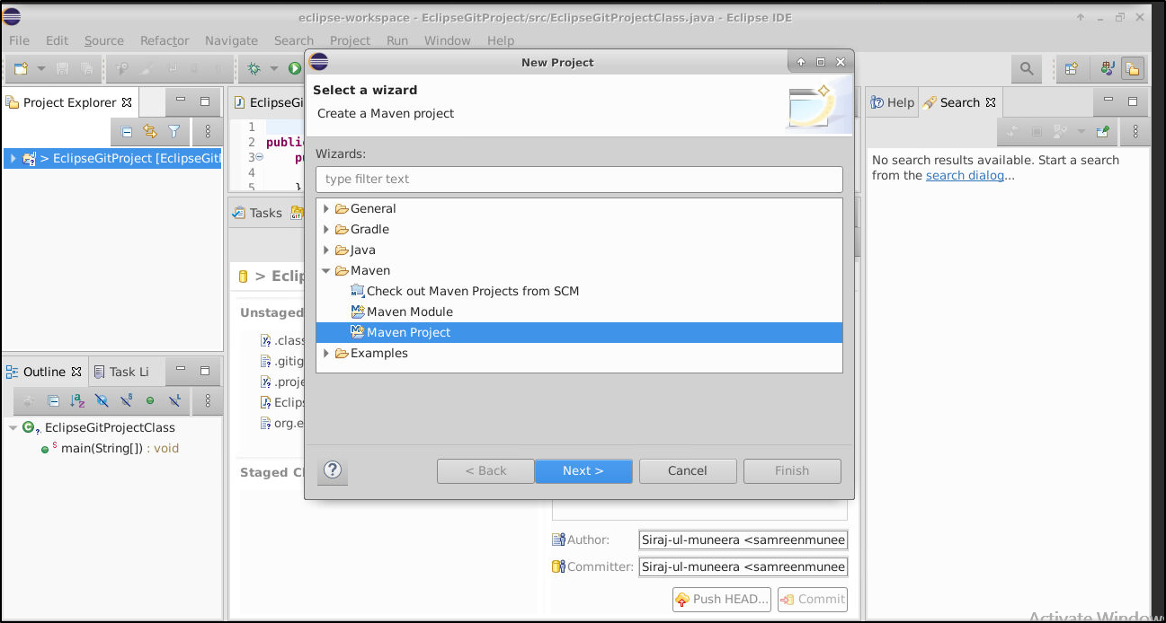

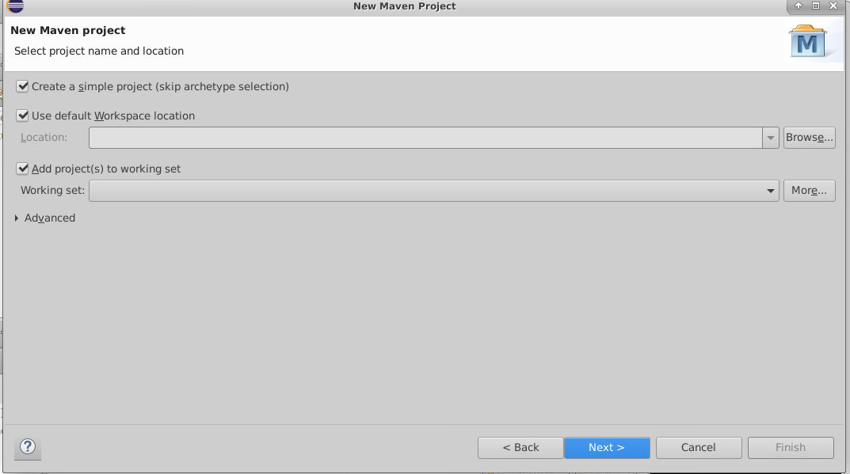
- In the New Maven Project Dialog box, enter the following details:
group id: simplilearn
artifact id: CloverDemo
- Add the below code in the pom.xml file .
<project xmlns="http://maven.apache.org/POM/4.0.0" xmlns:xsi="http://www.w3.org/2001/XMLSchema-instance" xsi:schemaLocation="http://maven.apache.org/POM/4.0.0 https://maven.apache.org/xsd/maven-4.0.0.xsd">
<modelVersion>4.0.0</modelVersion>
<groupId>simplilearn</groupId>
<artifactId>CloverDemo</artifactId>
<version>0.0.1-SNAPSHOT</version>
<build>
<plugins>
<plugin>
<groupId>com.atlassian.maven.plugins</groupId>
<artifactId>clover-maven-plugin</artifactId>
<configuration>
<generatePdf>true</generatePdf>
<generateXml>true</generateXml>
<generateHtml>false</generateHtml>
<generateJson>false</generateJson>
</configuration>
<executions>
<execution>
<phase>generate-sources</phase>
<goals>
<goal>instrument</goal>
</goals>
</execution>
</executions>
</plugin>
</plugins>
<pluginManagement>
<plugins>
<!-- This plugin's configuration is used to store Eclipse m2e settings only. It has no influence on the Maven build itself. -->
<plugin>
<groupId>org.eclipse.m2e</groupId>
<artifactId>lifecycle-mapping</artifactId>
<version>1.0.0</version>
<configuration>
<lifecycleMappingMetadata>
<pluginExecutions>
<pluginExecution>
<pluginExecutionFilter>
<groupId> com.atlassian.maven.plugins </groupId>
<artifactId> clover-maven-plugin </artifactId>
<versionRange>[4.1.2,)</versionRange>
<goals>
<goal>instrument</goal>
</goals>
</pluginExecutionFilter>
<action>
<ignore/>
</action>
</pluginExecution>
</pluginExecutions>
</lifecycleMappingMetadata>
</configuration>
</plugin>
</plugins>
</pluginManagement>
</build>
</project>
- After adding the code in pom.xml, right click on your project folder in eclipse and select maven-> update project.
- Install the Clover plugin via Manage Jenkins -> Manage Plugins.
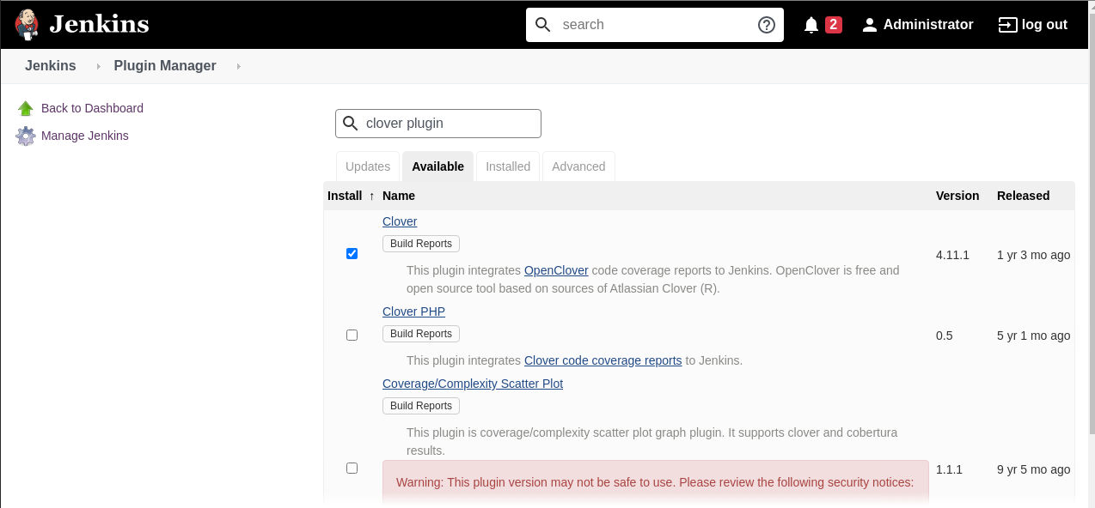

Step 6.4.3: Creating Jenkins job for Maven

- To create a new job in Jenkins, open the Jenkins dashboard with your Jenkins URL. For example, http://localhost:8081/
- Click on Create New Job. Enter the item name, select Maven Project and click OK.
- Once you click OK, the page will be redirected to its project form. Here, you will need to enter the project information.
- In the build section provide the location of the pom.xml file in your local system.
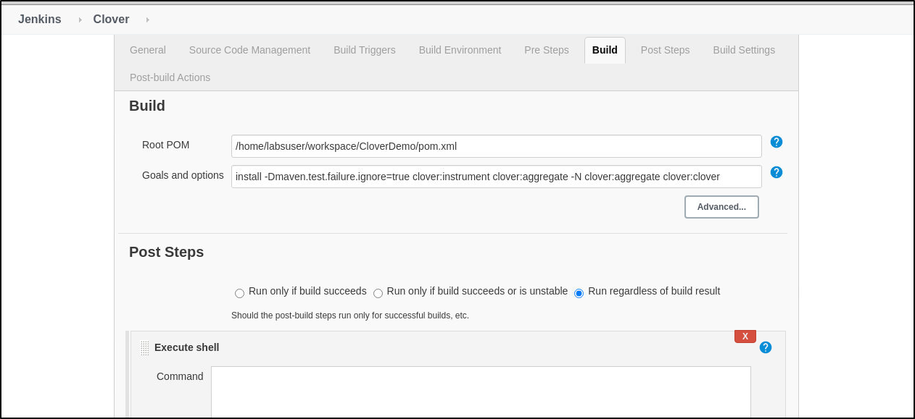
- In the build section specify the following goals and options for maven:
install -Dmaven.test.failure.ignore=true clover:instrument clover:aggregate -N clover:aggregate clover:clover

- Build the job.

Step 6.3.4: Push the code to your GitHub repositories

- Open your command prompt and navigate to the folder where you have created your files.
cd <folder path>
- Initialize your repository using the following command:
git init
- Add all the files to your Git repository using the following command:
git add .
- Commit the changes using the following command:
git commit . -m “Changes have been committed.”
- Push the files to the folder you initially created using the following command:
git push -u origin master

